Web Spine & Hinge with 6mm Fixed Hinge
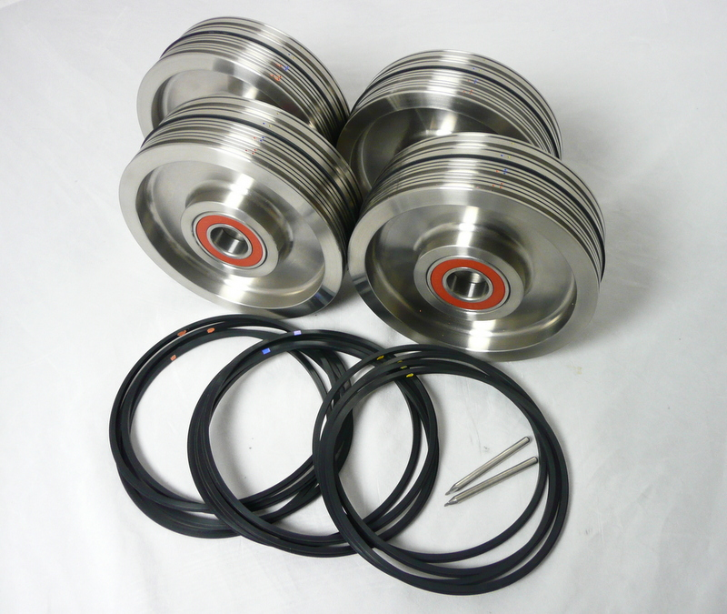

Contents of Package

4 x Male/Female Components:
(with bearings) 6 widths of crease channel with 4 settings preset at 6mm for Spine & Hinge creasing.
8 x Orange Dot /Black Gripper Crease (M-33A):
used to crease material weight between 70-150gsm
8 x Blue Dot /Black Gripper Crease (M-34):
used to crease material weight between 100-200gsm
8 x Yellow Dot /Black Gripper Crease (M-33):
used to crease material weight between 200-350gsm

6mm hinge light crease
6mm hinge medium crease
6mm hinge heavy crease
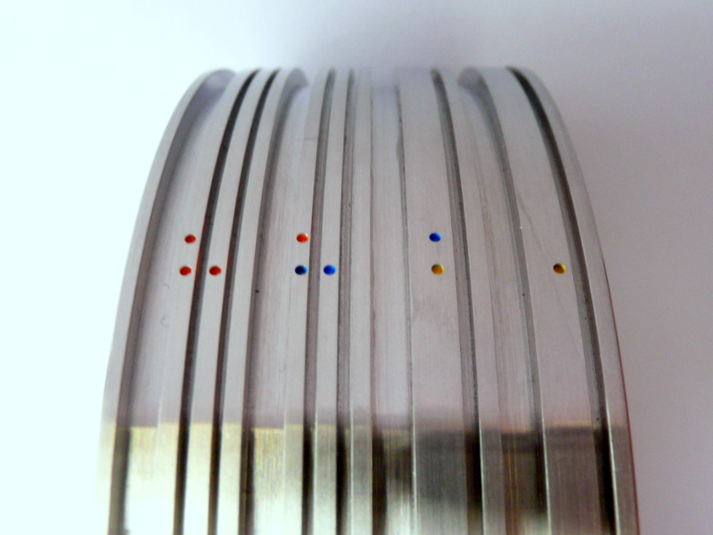

2 extra crease channels for standard single creasing

6mm hinge medium/heavy crease

The 4 settings above relate to a spine & hinge setting of 6mm apart

2 dot ORANGE, & 2 dot ORANGE & BLUE are extra standard channel settings that can be used with single creasing

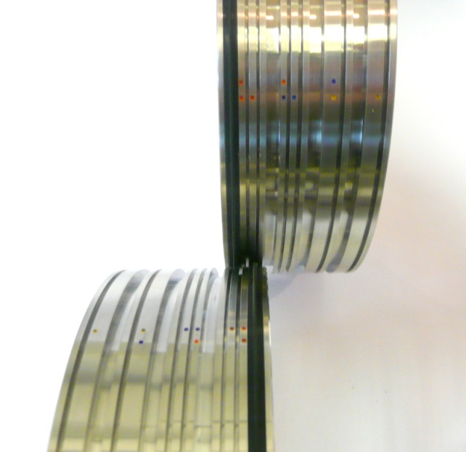
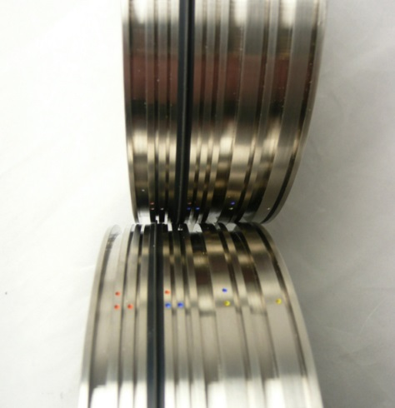

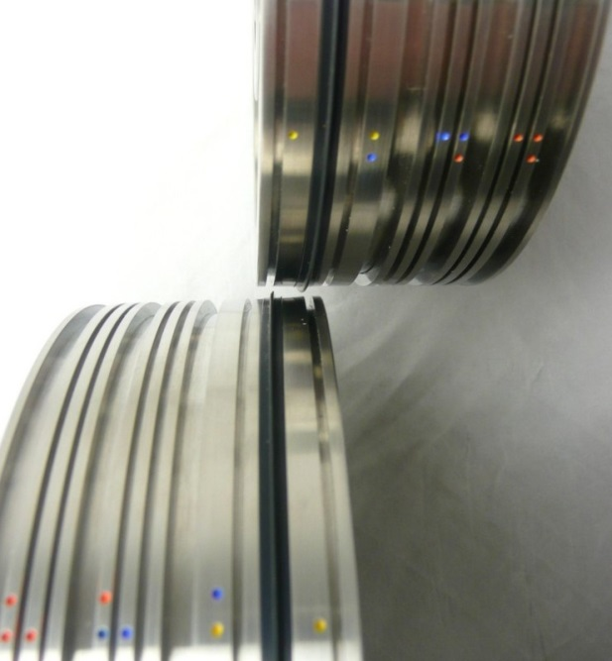
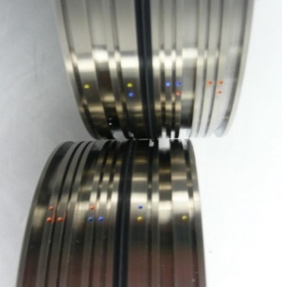
Yellow 1 dot setting
Blue / Yellow 2 dot setting
Orange 1 dot setting
Blue 1 dot setting

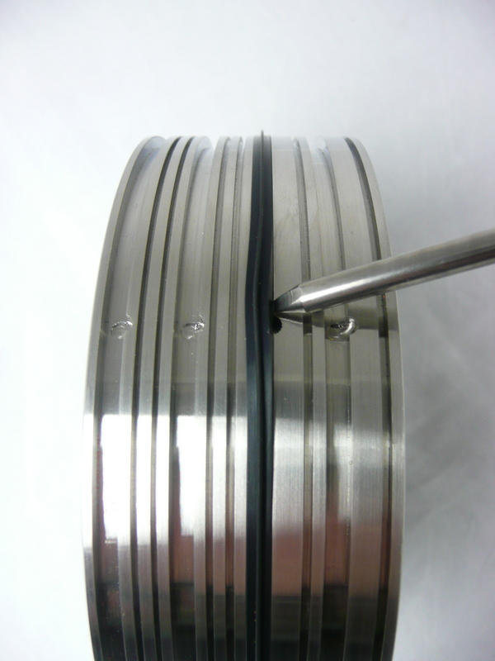
Crease Rib Extraction Tool

3 x colour coded crease ribs

